BOAT TOUR WITH D/S PRØVEN IN 2019
AT THE BORDER BRIDGE KORNSJØ / DALS HØGEN
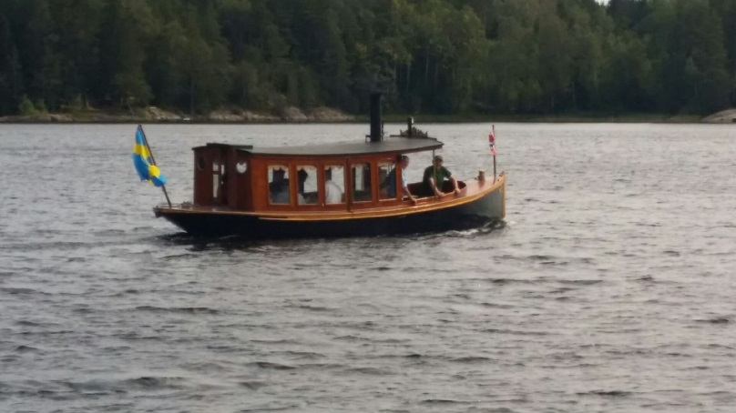

KORNSJØ STEAM BOAT COMPANY OFFERS:
TRIPS: Saturday and Sunday from week 25 until and including week 34.

Departing from our landing pier at 12.00 p.m. lasting one hour.
Seat should preferably be ordered in advance, tel: (+47) 977 40 183

Price adults NOK 100, children 7 – 16 years NOK 50, under 7 years, free.
The boat has space for maximum 10 passengers

CHARTER TOURS: We also offer charter tours on Kornsjøen as of May until and including the month of September. This trip should be ordered at the latest at 18.00 p.m. one day in advance. The price is NOK 1000 per. hour.

For orders and further information: tel. ( +47 ) 977 40 183

The boat trip could be combined with a good meal in Grensestua

Visit us on kornsjo.no Follow us on facebook

WELCOME TO AN UNFORGETTABLE TOUR ON THE BEAUTIFUL KORNSJØEN

